Additive manufacture with graded bio-polymer composites
Nicholas, Paul¹[0000-0003-2420-8351] and Eppinger, Carl¹[0000-0003-3828-9172] and Chiujdea, Ruxandra¹[0000-0001-9610-7125] and Sonne, Konrad ¹[0009-0008-7029-9008] and Ramsgaard Thomsen, Mette¹[0000-0002-3093-8556]
¹ Center for Information Technology and Architecture (CITA), Royal Danish Academy, Philip de Langes Allé 10, 1435 Copenhagen K, Denmark
{paul.nicholas/cepp/rchi/kson/mette.thomsen}@kglakademi.dk
Abstract. Bio-based materials are emerging a key alternative for carbon-intensive construction materials, which are becoming increasingly ill-suited to society’s ambitions to decarbonize construction. Beyond already established low carbon biomaterials such as timber, locally sourced second and third generation waste and side-stream biomass is recognized as having significant potential to be used in architectural elements. However, the use of these materials requires processing routes based in contemporary design and fabrication technologies. Additive manufacturing is one such route. This paper outlines an approach for graded 3D printing with a biopolymer-composite that incorporates local waste and agricultural side stream residues. In this paper, we describe the underlying motivations, challenges and opportunities for multi-material grading, and detail the development stages of a custom-built robotic tool and feeding system that enables continuous grading of two or three material inputs. Further, we explain the complications involved with material viscosity changes and the correlation to the design of the printing toolpath. We demonstrate the use of the custom-built robotic tool and feeding system on a set of architectural-scale weather screen panels, using different biopolymer mixtures and grading strategies.
Keywords: biopolymer composites, robotic 3D printing, material grading
- Introduction
Architecture is engaging on a transformative shift towards biomaterials as a central part of its efforts to decarbonize the built environment. Biomaterials not only sequester carbon during their growth phase but also have a significantly reduced carbon footprint in their processing and production compared to more conventional construction materials such as concrete and steel. While timber, especially in the form of cross-laminated timber and other engineered wood products, is the leading biomaterial used in construction, it cannot be relied on alone, as increasing timber consumption would further challenge sustainable forestry practices (O’Brien and Bringezu 2017). Furthermore, different architectural applications require materials with different structural or visual properties and performances. It is therefore important to diversify the range of sustainable biomaterials used in architecture and to develop processing routes for them that take advantage of contemporary design and fabrication technologies.
This paper describes the graded robotic 3D printing of a bio-based polymer composite. This material combines a collagen-based biopolymer with fibrous and filler materials that are also generated from biomass and the growth of microorganisms and plants. Grading different composites, allows to precisely distribute materials based on their mechanical performance. Rather than using virgin sources, the fibers and fillers are sourced from 2nd and 3rd generation feedstocks: biological residues and waste streams that would otherwise be burnt, landfilled, or left to decay. Valorizing them within 3D printed architectural elements stores and transfers their carbon into architectural material flows, helping to enable the built environment to become a store of atmospheric carbon.
However, these inherently local material resources introduce a new dynamic to the sourcing and flow of resources. Their quantity and quality are not constant – they are seasonally dependent, connected with local agricultural practice and terroir, and their properties vary in line with weather and climate. As new resource loops emerge within the circular bioeconomy they stop being wastes and raise in value. In summary, their continuous ready availability and perceived abundance cannot be assumed. To scale the use of this class of bio-based polymer composite within architectural 3D printing will therefore require modes of material specification and production that can address two criteria: material flexibility – the ability to interchange fillers and fibers in response to local material availability, and material optimization – the ability to specify the distribution of a graded material in response to design or performance criteria.
Our paper introduces the design of an extruder system that aims to address both of these criteria by enabling material grading. In the paper, we firstly describe state of the art in robotic 3D printing with bio-based materials for architectural applications, and then detail the specific challenges associated with our biopolymer composite material. We then outline the design and development of a system for the graded extrusion of a collagen-based bio polymer composite material. Through the description of four stages of design evolution, we address the key considerations that have informed the system design. These include material-based considerations, the mixing of multiple material feeds, the implementation of continuous feeding from a separated reservoir, and the grading control in the fabrication code. Lastly, the publication describes the application of our graded printing system to fabricate architectural scale wall panels that perform a weather screen function, and concludes with a discussion of these results and identification of the next steps that they imply.

- State of the Art
The necessity to replace conventional building materials with more sustainable alternatives is a key driver for the construction industry (Pamu and Alugubelli 2023). Biopolymers and biopolymer composites are a particularly promising alternative. They can use less energy to produce and are in many cases by-products or waste products of other industries, activating cascading and recycling cycles (Plank 2004; Aaliya et al. 2021). Architecturally-oriented research has explored different sources and compositions of biopolymer (Bever and Duwez 1972) including chitin, cellulose or casein, as well as the use of different concentrations of these polymers with varying uses of fillers or fibers (Rech et al. 2021; Pradhan et al. 2021). The inherent properties of those materials have been linked to design explorations of transparency and translucency, color variation or structural value (Tusnim et al. 2020). Research that has created composites combining biopolymers with similar material states, viscosities and workability, but with different properties of the finished product(Lee et al. 2020), points to the vast further opportunities for research and application of biopolymers within architecture..
Realizing these possibilities within architectural elements is to a large extent dependent on fabrication processes. Much of the initial research has been achieved using small scale casting and molding approaches, with the aim of exploring recipes and producing simple geometries to enable assessment of material properties (Tarangini et al. 2023). 3D printing, an inherently scalable technology, has the potential to greatly enlarge the design space as well as the size of printed elements (Rossi et al. 2022, Sanandiya et al. 2018). However, this fabrication method also requires that a more complicated set of considerations need to be taken into account. These challenges include creating a printable material, controlling the transition of the material from viscous to firm across the printing process, and combining multiple material feeds of differing viscosities within a single print.
A small amount of literature reports multi-material robotic 3d printing with biopolymers. These investigations have focused on printing biopolymers without fillers (Mogas-Soldevila et al. 2015) or have developed approaches based on co-extrusion instead of material mixing within the printing process (Seibold et al. 2019). While co extrusion enables two different materials, with different material properties, to be combined within one print, this method does not enable their continuous combination and mixing. A further approach to grading sequentially deposits different material recipes in a set order which then combine into a single graded result. In this approach, the exchange of tool or material during the printing process is highly time consuming and still limits the possibility of seamless material blending. (Lesna et al. 2020; Mogas-Soldevila et al 2014).
- Method
  - Collagen Glue Based Biopolymer
The biopolymer used in this investigation is composed of a mixture of collagen glue, water and glycerin. Compared to other common polymers used for 3d printing, this biopolymer enables significant adaptability to incorporate different fillers, as well as an ongoing thermoplastic response, however is also temperature sensitive and highly viscous. The biopolymer’s adhesive quality enables strong interlayer fusion and bonding, as well as a highly consistent adhesion to the print bed. These properties favor the creation of more extensive prints, without the possibility of failure towards the end of the fabrication, however also create challenges both in the design of the extruder as well as the design of the printing path.

The high viscosity of the collagen-based biopolymer disrupts the mechanical components of valves, gates and monitoring devices that come in direct contact with the material. This impacts the design of the extruder and delivery system by limiting such flow-control devices to those that only have indirect contact with the material.
The temperature sensitivity of the collagen-based biopolymer requires a precisely controllable and closed heating system to control the viscosity of the material throughout the entire material feed. This requested the system to be able to react to the material’s temperature, to guarantee a lower viscosity during the material feeding, but a higher viscosity at the point of extrusion to create a stable material bead.
At the level of the print path, the adherence of the polymer to both the extruder and itself also creates challenges. As the material is less deposited by the extruder, but more pulled out, by adhering to previously printed material or the print bed, free standing directional changes become challenging and must be approached through the design of the print path through methods such as short pauses at critical moments, as well as print geometry and direction control.
The introduction of different fillers introduces further considerations. To create the biopolymer composite, the biopolymer is mixed with varying combinations of three fillers – cotton, wood flour and bark. The grading of these fillers, such as a change from lower density materials like cotton to high density materials such as seagrass, impacts the viscosity of the material within the extruder, as well as the mechanical performance of the material once it is dried. As the composites are mixed by ratios of filler weight, cotton or wood flour drastically increase the volume of the material thus reducing the viscosity.. The young’s modulus varies between 2,51 GPa for a mixture of 6% cotton fiber by weight and 2,43 GPa for a 10% wood flour mixture.
  - Extruder Development
The custom extruder was developed in four stages, with each stage considering one major aspect of the intended goal of graded extrusion. The initial stage consisted of designing a single material extruder, without any grading capabilities, to understand the material and the implications of printing with different fiber ratios. The extruder was built out of a combination of aluminum and nylon. The majority of the extruder body was made of different sized aluminum tube extrusion, taking advantage of its high thermal conductivity and lightness, with custom parts manufactured using selective laser sintering of nylon. Key considerations in the choice of both materials was their ability to withstand the temperature of the biopolymer, which can reach up to 70°C, robustness against abrasions from the fillers, reduction of the possibility of the collagen bonding with the extruder, and easy cleanability. The extruder was fed using a heated pneumatic pump. The second stage of the tool development (Fig.1, left) tested a first incorporation of material grading. For this the initial extruder design was adapted to include two additional separate canisters. These could be individually controlled to add material accents to a continuously feeding base material.

Due to the different fiber ratios, the two additional materials needed to be kept at different temperatures, between 39°C and 45°C, to create an equal level of viscosity throughout the printing system. This included a separated heating system using resistance wires coated in silicone and separate heating controls, adjusted based on the optimal material temperatures.

In the third stage (Fig.1, top right), the extruder was redesigned to implement insights gathered from the previous stages, most notably the difference in material flow between the base material feed and the accent material reservoirs. The additional reservoirs were removed and replaced by two more connections to external continuous feeding systems. To stop the residual flow and buildup of pressure, those connections were equipped with pneumatic cylinders acting as pinch valves. This constraint reduced the amount of buffer material to the material already in the extruder core and thus limited the time the secondary material needed to replace the initially printing primary material. Smaller adjustments were made to simplify the printing process, such as the integration of an overflow limit switch. This adjustment reduced the impact of the pressure used in the pump, as the limit switch closes the valve and cut the pressure to give the extruder time to process the material build up before restarting the material feed.

After testing with this tool, which greatly improved the consistency and effect of grading, the decision was made to develop a reduced version of this extruder (Fig.1, bottom right). This design reduces the time taken to change between materials by reducing the material held within the extruder itself, in turn enabling more immediate grading strategies. In all stages the material mixing was controlled through the flow rate as the auger screw feeding the material also acted as a tool to homogenize the materials. The reduction in volume of this last stage omitted the necessity for the previously added pinch valves, as the volume where both material feeds would meet was severely reduced and used only to mix the material grade.
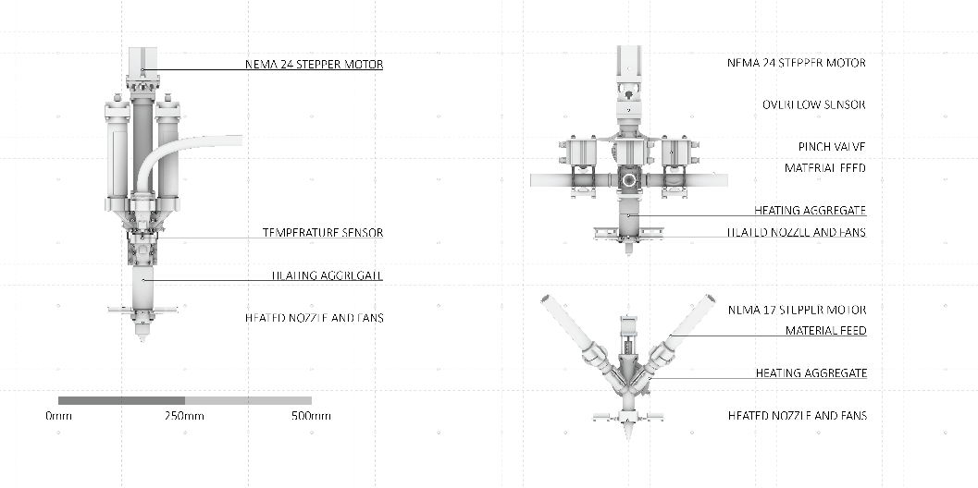
Fig. 1. Extruder development; from left to right: Stage 2 extruder with accent material reservoirs, Stage 3 extruder with pinch valves and additional material feeds, Stage 4 extruder with reduced extruder body.

  - Continuous Material Feeding Systems
During the process of extruder development it became clear that the use of one-liter reservoirs would greatly limit the extent of printing. Direct experience showed that replacing and refilling these reservoirs during the print resulted in inconsistent print qualities due to the fluctuation in material flow. To address this problem the small reservoirs were replaced with an external material feeding system that could hold three liters of material and be refilled without interruption to the printing process. This reservoir and pneumatic pump were developed by World Advanced Savings Project (WASP,2024) . During the initial grading tests with the stage 2 extruder it became clear that for controllable grading the materials need to be fed at a similar rate, which required a secondary pump. This additional pump and feeding system was built on the same basic principles as the WASP system, using pneumatics to feed the material (Fig.2). Coordinated control for both pneumatic pumps was programmed into the robotic code, with Digital Outputs used to open or close the input of compressed air. The selected pressure was controlled by the operator to allow for a higher degree of intervention during the print.

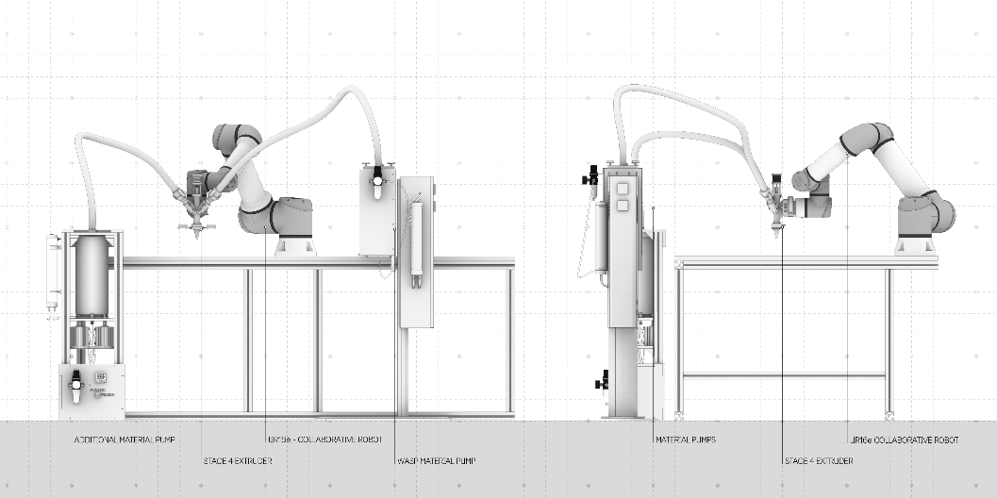
Fig. 2. Robotic fabrication setup; Universal Robots UR16e equipped with two material feeds and Stage 4 extruder.
  - Grading Test Strategy
Understanding the time necessary to switch between two materials is critical to be able to precisely plan and print graded geometries. To determine this parameter, a simple test geometry was developed where the frequency of switches between two separate material feeds was incrementally increased to understand the behavior of the material before, during and after switching. The test geometry consisted of a 30 centimeter by 30-centimeter panel, where lines in a five-millimeter offset were printed. Each test consisted of running the test twice, producing two layers on the same geometry. The first layer switched from an initial material, here called material “A” to a material with different filler content, here called material “B”. The second layer switched back to the initial material. With the print path being regular, this allowed to measure the length of print, as well as the volume of material, necessary to switch from one material to the other. The result of these tests showed that, the previously mentioned, larger extruder, while able to switch from one material to another, took a lot of time and volume between material switches, which led to the development of the latest iteration. Furthermore, the tests revealed, that the choice of materials greatly impacted the form the gradient took while switching materials. These tests (Fig.3) were done using the same two materials mixtures, but with different switching frequencies. The chosen material recipes were, for material “A”, a mixture of collagen glue containing a filler of 10% wood flour by weight, and for material “B” a mixture of collagen glue containing a 6%bark fiber filler. The materials used in these experiments were sourced and processed as described in “Extending The Circular Design Framework For Bio-Based Materials: Reconsidering Cascading And Agency Through The Case of Biopolymer Composites”(2023) . In test 1 (Fig.3, far left), the extruder was purged of any traces of material “B” before the print started and then switched from material “A” to material “B” in the center of the print. On the second layer the same strategy was used but switching back to material “A”. The resulting print was then easily analyzable, by identifying the point the material feeds were switched and measuring the distance to the first instance material “B” had purged out the entirety of material “A”. In the second and third tests (Fig.3, center and far right) the frequency of material changes was raised to one third of the print and one fifth of the print length between material shifts.

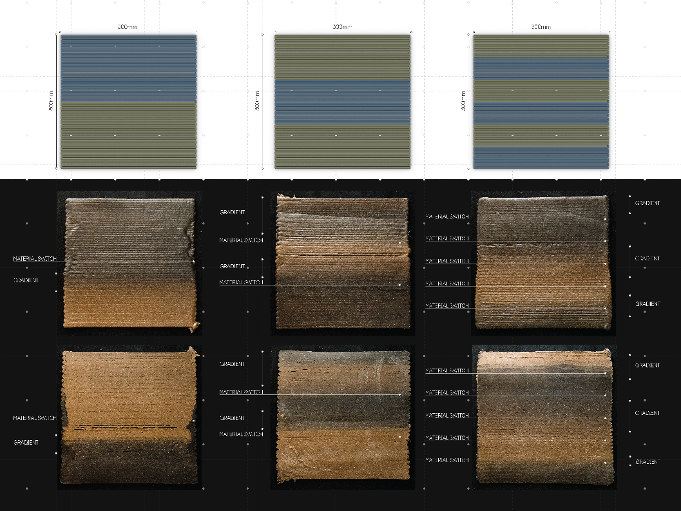
Fig. 3. Initial grading tests; Increasing the material switching frequency throughout iterations
  - Material Switching Delay
Throughout those tests the observation was made, that the volume of the extruder shared by both materials has a significant impact on the delay between the initiation of flow of the material to be printed and the time the material appears, homogenous at the nozzle. This volume translates into the length of the gradient within the printed geometry. This observation was the initial consequence for the design of the stage 4 extruder, which has a smaller volume in the extruder and can thus switch between materials faster. While the stage 3 extruder would need eighteen meters of print, using a four-millimeter nozzle, the reduced stage 4 extruder is able to switch within three meters, using the same nozzle diameter (Fig.4). It was furthermore observed, that increasing the switching frequency to appoint where the secondary material does not have enough time to fully replace the initial material will create a continuous blend of the two materials, with little control over the exact composition. This can be especially observed in the third iteration of the grading tests (Fig.3), where the material gradients become less defined, as well as more irregular throughout the print. This examination gave a clear design constraint for further explorations, and the design of the material feeding control throughout the print path.
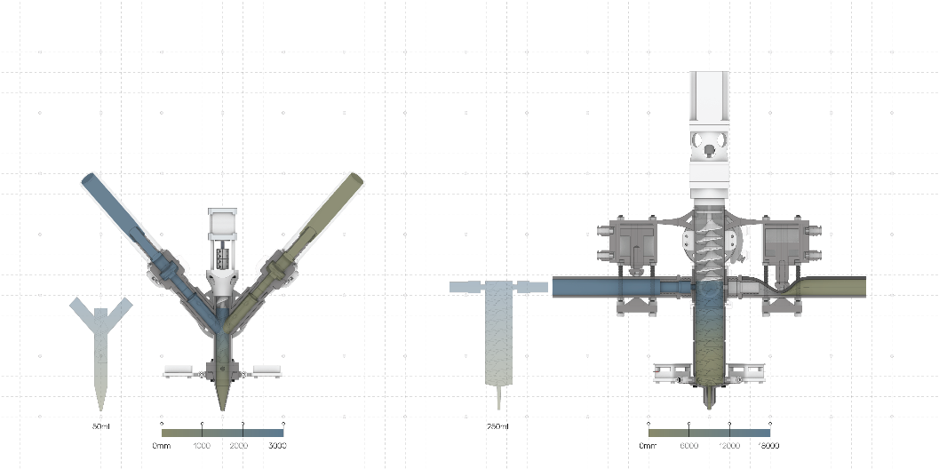
Fig. 4. Material Switching Delay comparison between Stage 4 and Stage 3 Extruders
- Application of graded printing on building scale panels
  - Three-tiered Building Scale Panel Design Geometry
These observations were implemented in a set of three architectural scale panels, which were all designed with different grading strategies, applied to the same geometry. The panel is designed using a growth algorithm for variation of printing geometries as well as for aesthetic purposes, with the intended use as weather screens, modulating the impact of rain and wind. The panels combine three design features each with their own function – the base, the sacrificial layer and the stitching The first feature, the base, consists of four layers of collagen glue material, printed inside the boundary of a parallelogram of 350mm by 700mm. This base creates a perforated surface, adaptable for cladding a larger surface. Itself is separated into four larger fields of perforated print path and two solid end-pieces. The second design feature, the sacrificial layer, acts as a protective layer for the base. This geometry is designed as two horizontal extrusions, spanning the entire width of the panel. To minimize the footprint while still creating a large protective area, the sacrificial layer skews in a 30° overhang, which was considered the maximum inclination possible with the biopolymer composite using bark fiber. The last feature of the design, the stitching, creates a connection between the sacrificial layer and the base. This geometry uses the same growth algorithm, however with the branches growing in the opposite direction of the sacrificial layer and the base to connect multiple branches of the lower layers together.
This three-tiered panel geometry shows a wide variety of challenging print paths. From the growth algorithm-based branching, which includes small radii, fast directional changes, as well as long straight lines to the overhangs in the sacrificial layer and the bridging of the stitching layers over the base layer.
  - Grading Strategy and Expected Outcome
From what was learned through the grading control tests, three different grading strategies were applied to the panel geometry. The different grading strategies were applied with an understanding of the material change delay, switching material in different intervals to receive the desired outcome. In the first iteration(Fig.5, far left), each field of the base was split in half and then shifted from field to field, creating a checkered pattern. The goal being to extend the time a material is printed before the switch of material occurs. The expected outcome was a global gradient from the bottom of the panel to the center and another from the center to the top of the panel. The sacrificial layer and stitching layer were divided, and each assigned a different material. The expected outcome was that the gradient would occur in the center of the individual sections, with the material distribution inverted between the sacrificial layer and the stitching layer. The second grading strategy (Fig.5, center) splits the base in similar sized sections, however instead of shifting the material distribution between each field, the application of Material A is shifted less and less throughout the different fields. This approach was expected to allow for a gradient in a globally transverse fashion. The sacrificial layer and stitching layer were applied with grading strategies, that would allow for the initial material to be purged out and replaced by the secondary material towards the end of each layer, thus the expectation was, that the printed outcome would be similar to the grading strategy of the first panel. In the base of the last panel (Fig.5, far right), the grading scheme steadily increased the delay of switching between the initial material and the secondary material. The expected outcome being a single, longitudinal gradient throughout the entire panel. On the sacrificial layer the grading strategy used the height of the section to increase the amount of the secondary material to create a gradient as the print rises. The stitching layer was sectioned in a similar fashion as in the second iteration, however the assigned materials were distributed in a way, that the expected outcome would create a longitudinal gradient between the two parts of the sacrificial layer.
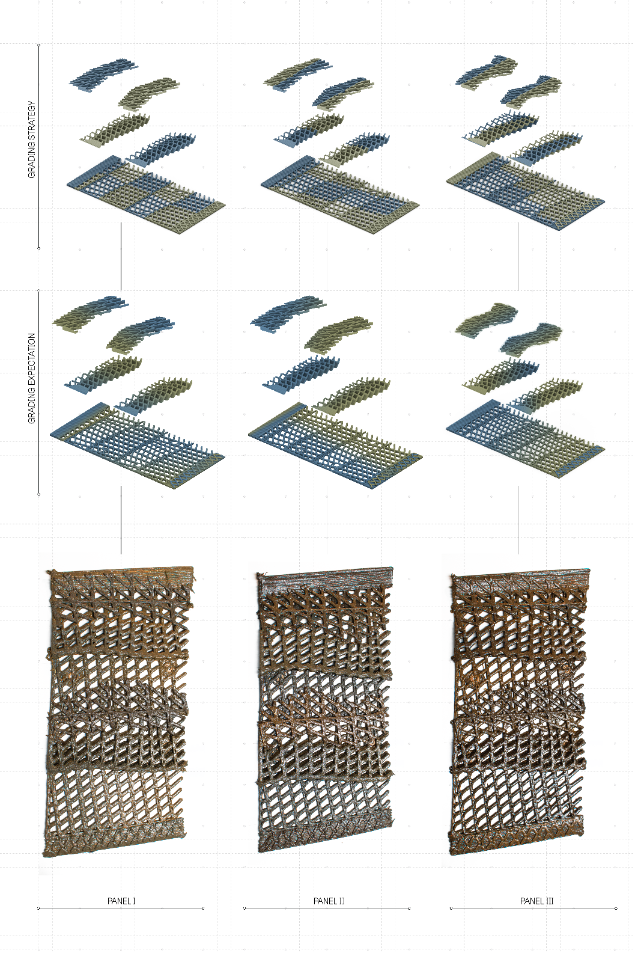
Fig. 5. Grading Strategy showing the distribution for 6% Cotton mixture (Blue) and 10%Woodflour 1% Cotton mixture (Tan), Grading Expectations and Final Outcome of Building Scale panels
  - Chosen Materials
The three chosen materials were chosen for their similarity in viscosity, as well as their color variation, to create three easily comparable prints. The mixtures were all collagen based with different amounts and variations of fibers. The cotton mixture, recognizable by its distinct blue hue, consisted of a 94% base biopolymer mixture and a 6% cotton mixture. As a easily printable and recognizable material, it was used as a benchmark to be matched by the other materials in printability and viscosity. The darker brown material consists of a 91% base biopolymer with a 6% bark fiber, sourced from the forestry industry, and 3% cotton fiber addition, to match the viscosity of the cotton mixture. Lastly, a wood flour mixture was created, which consisted of 89% biopolymer, 10% wood flour and 1% cotton fiber. This mixture is very visibly detectable by its tan hue, as well as the higher grain size of the wood flour, compared to the other fillers, which was a visible marker within the gradient prints to detect residue of this mixture in the prints.

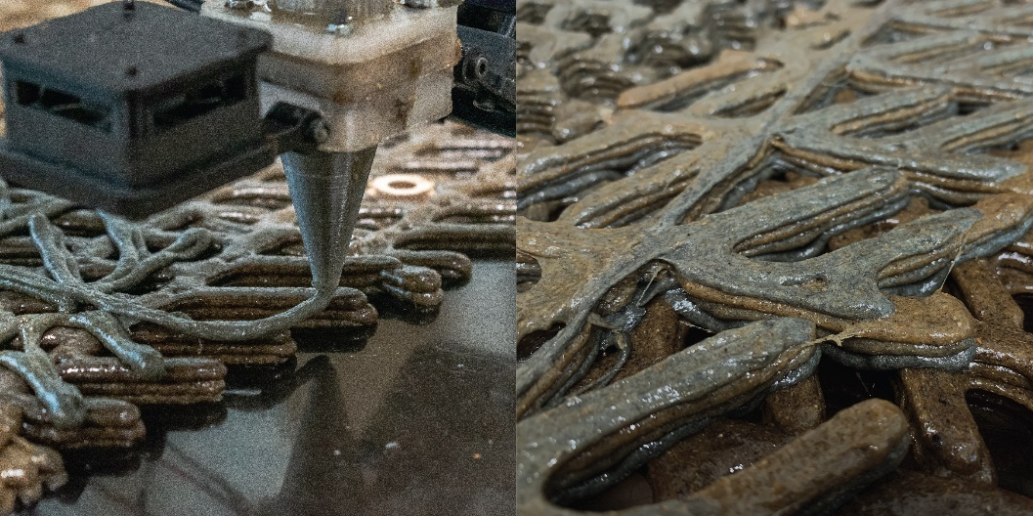
Fig. 6. Printing Process of Graded Biopolymer Panels

  - Printed Outcome
The grading strategies were shifted along the print path to trigger the different feeding systems with a 3000mm lead to the center of the gradient. This lead was determined through the aforementioned, initial grading tests (Fig.3). This scheme allowed to print the panels, as expected with clearly defined gradients on a global scale. The three chosen materials behaved as planned, with their viscosity, tensile strength during printing and printing temperature being nearly identical, the changes between materials, and thus the gradients behaved similarly between all combinations of materiality. This gave the possibility to clearly identify the gradient lengths and placements.
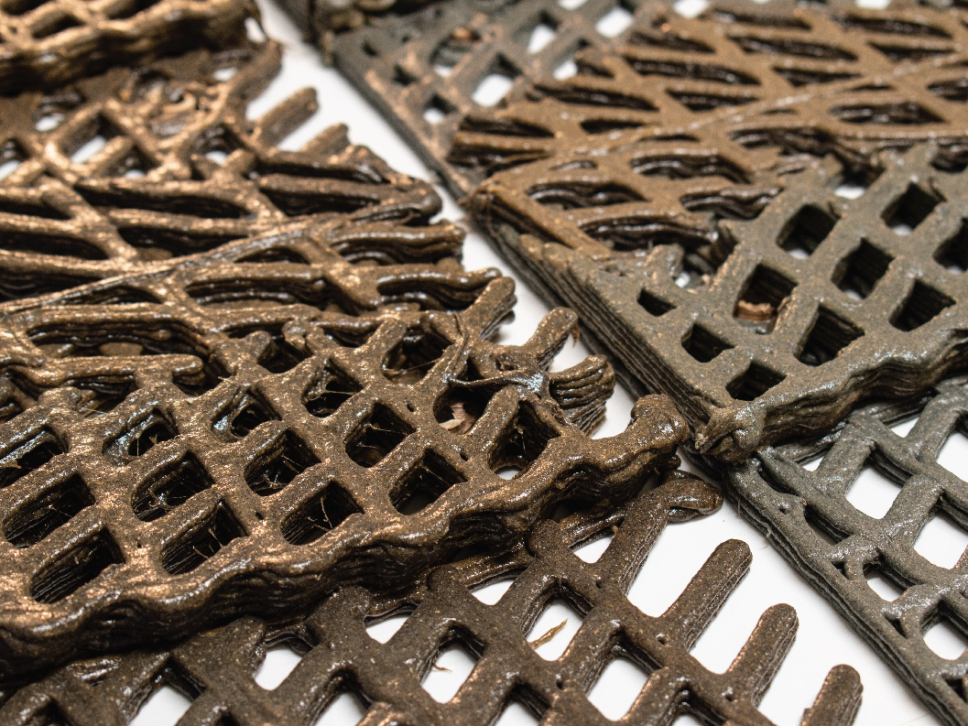
Fig. 7. Final Printed Outcome: Panel 1 & Panel 2
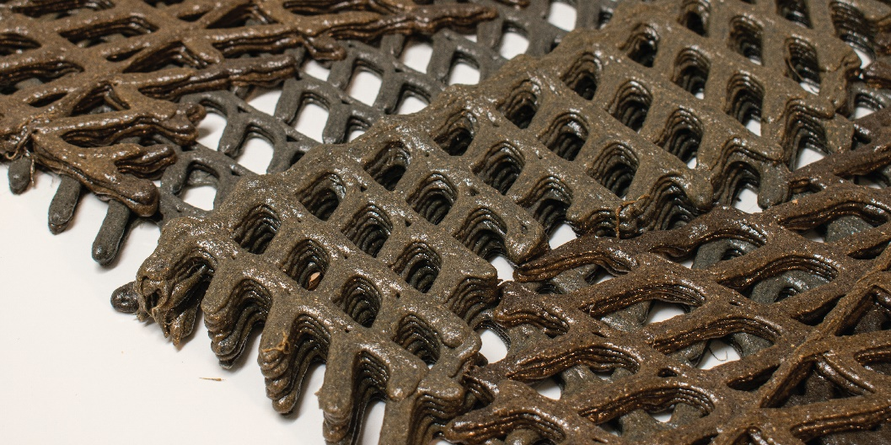
Fig. 8. Final Printed Outcome: Panel 3
- Conclusion & Further Development
Our paper has introduced a graded 3D printing system for waste and side stream-based biopolymer composites. We are able to print with varying fillers and fibers, and therefore varying viscosities, making the process robust to variable quantities of local resource. By incorporating consideration of the influential parameters into the design of the overall print system and specific tooling, we have developed a printing approach capable of fabricating large-scale geometries with designed material distributions, material gradients and material properties to an architecturally acceptable degree of accuracy. Using multiple feeding systems with large material reservoirs, we are able to print graded architectural scale elements in one continuous process without the need to pause for material changes.
While printing different materials with varying degrees of fiber and filler creates a challenging condition of managing varying viscosities, our findings point towards the potential of fabrication approaches that are flexible with regard to these material parameters. The ability to maintain different temperatures for different material feeds, achieved through independent heating systems, underscores the flexibility in utilizing biopolymers and their mixtures at their ideal printing temperatures. The extruder we introduced in this paper can grade varied, heated materials within a short printing span and supports controlled grading at both a detail as well as a global geometry scale. This rapid grading facilitates continuous material variations and potential mixtures at varying rates during the print, achieving high-precision graded 3D printed geometries. It can be further adapted to ensure targeted material distributions based on the visual and structural traits of different biopolymer compositions.
Future research will focus on refining the heating system to adjust to in-process variations and handling material grading with a broader viscosity range for increased material versatility. Although our latest extruder design can transition between materials efficiently, further development is planned to reduce transition time, allow for shorter gradients and more controlled mixing, and grade three material variations of different compositions and viscosities to enable more complex grading strategies Further, we aim to extend our use of natural and recycled fillers and fibers to further broaden the material palette and incorporate local materials. Introducing fillers and fibers from different geographical regions, could further cement the adaptability of the material around the globe, using readily available materials.

Acknowledgements
This project has received funding from the European Research Council (ERC) under the European Union’s Horizon 2020 research and innovation programme (grant agreement No 101019693).
The manuscript was written with the contribution of all authors. All authors have approved the final version of the manuscript. Nicholas, P. project conceptualization, methodology, design concept, writing – original draft, reviewing and editing, supervision, Eppinger, C., design concept, 3D print hardware development, prototyping, fabrication, writing – original draft, reviewing and editing, Chiujdea, R., design concept, prototyping Sonne, K., prototyping, fabrication, Ramsgaard Thomsen, M. project conceptualization, methodology, design concept, writing – original draft, writing – review and editing, lab infrastructure, supervision, funding acquisition.

References

- O’Brien, M.; Bringezu, S. What Is a Sustainable Level of Timber Consumption in the EU: Toward Global and EU Benchmarks for Sustainable Forest Use. Sustainability, 9, 812. (2017) https://doi.org/10.3390/su9050812
- Pamu, Y., Alugubelli, S.: A comparative study of environmental impacts due to conventional and sustainable concrete. Materials Today: Proceedings.(2013)
- Plank,J.: Applications of biopolymers and other biotechnological products in building materials. Applied Microbiology and Biotechnology 66, 1-9(2004)
- Aaliya, B., Sunooj, K., Lackner,M.: Biopolymer composites: A review. International Journal of Biobased Plastics 3(1), 40-84(2021)
- Bever, M., Duwez, P.,: Gradients in composite Materials. Materials Science and Engineering 10. 1-8(1972).
- Rech. A., Nicholas. P., Ramsgaard Thomsen, M., Dougaard, A.,: Waste-based biopolymer slurry for 3D printing with recycled materials. In: Nordic Polymer Days 2021, Online (2021)
- Pradhan, R., Rahman,S., Qureshi,A., Ullah,A.,: “Biopolymer: Opportunities and Challenges for 3D Printing.” Essay. In Biopolymers and Their Industrial Applications: From Plant, Animal, and Marine Sources, to Functional Products, Sabu,T., Gopi,S., and Amalraj,A. (eds.) 281–303. Elsevier, 2021.
- Tusnim, J., Hoque, M. E., & Biswas, M. C. (2020). Chapter 12—Biopolymers in Building Materials. In F. M. Al-Oqla & S. M. Sapuan (Eds.), Advanced Processing, Properties, and Applications of Starch and Other Bio-Based Polymers (pp. 185–195). Elsevier. https://doi.org/10.1016/B978-0-12-819661-8.00012-3
- Lee,N., Weber, R., Kennedy, J., Van Zak, J., Smith, M., Duro-Royo, J., Oxman, N.: Sequential Multimaterial Additive Manufacturing of Funcionally Graded Biopolymer Composites. 3D Printing and Additive Manufacturing 7(5), 205-215 (2020)
- Tarangini, K., Huthaash, K., Kumar, V., Kumar, S., Jayakumar, O., Waclawek, S., Rao, K., Padil, V.: Eco-Friendly Bioplastic Material Development Via Sustainable Seaweed Biocomposite. Ecological Chemistry and Engineering S. 30, 333-341(2023)
- Rossi, G., Chiujdea, R., Hochegger, L., Lharchi, A., Nicholas, P., Tamke, M., Ramsgaard Thomsen, M.: Integrated design strategies for multi-scalar biopolymer robotic 3D printing. In: Aviv, D., Jamelle, H., Stuart-Smith, R., Akbarzadeh, M. (eds.) Hybrids & Haecceities, pp. 346-355, ACADIA, Philadelphia (2022)
- Sanandiya, N., Vijay, Y., Dimopoulou, M., Dritsas, S., Fernandez, G.: Large-scale additive manufacturing with bioinspired cellulosic materials. Scientific Reports 8, 8642 (2018)
- Mogas-Soldevila, L., Duro-Royo, J., Lizardo, D., Kayser, M., Sharma, S., Keating, S., Klein, J., Inamura, C., Oxman, N.: Designing the Ocean Pavilion: Biomaterial Templating of Structural, Manufacturing and Environmental Performance. In: Proceedings of the International Association for Shell and Spatial Structures (IASS), pp. 1-13, Amsterdam (2015)
- Seibold, Z., Mhatre, S., López, J., Alhadidi, S., Bechthold, M.: Janus Printing: Co-Extrusion based Multi-material Additive Manufacturing for Ceramics. In: Bieg, K., Briscoe, D., Odom, C. (eds.) Ubiquity & Autonomy, pp. 576-585 ,ACADIA, Austin (2019)
- Lesna, J., Nicholas, P.: De Gradus – Programming heterogeneous performance of functionally graded bio-polyerms for degradable agricultural shading structures In: Holzer, D., Nakapan, W., Globa, A., Koh, I.(eds.) Anthropocene. Design in the Age of Humans, pp. 385-394, CAADRIA, Bangkok(2020)
- Mogas-Soldevilla, L., Duro-Royo, J., Oxman, N.: Water-based Robotic Fabrication: Large-Scale Additive Manufacturing of Functionally Graded Hydrogel Composites via Multichamber Extrusion. 3D Printing and Additive Manufacturing 1(3), 141-151 (2014)
- WASP. (2024, February 1). Stampanti 3D | WASP | Azienda leader nel settore della stampa 3D. Stampanti 3D | WASP. https://www.3dwasp.com/
- Rosenthal, M., Henneberger, C., Gutkes, A., Bues, C.: Liquid Deposition Modeling: a promising approach for 3D printing of wood. European Journal of Wood and Wood Products 76, 797-799 (2018)
- Ramsgaard Thomsen, M., Nicholas, P., Rossi, G., Daugaard, A., Rech, A.: Extending The Circular Design Framework For Bio-Based Materials: Reconsidering Cascading And Agency Through The Case Of Biopolymer Composites. Design for Rethinking Resources, Proceedings of the UIA World Congress of Architects, Copenhagen (2023)

